Procedures to file a request to JPO (Japan Patent Office) for Patent Prosecution Highway Pilot Program between JPO and IP Viet Nam (Intellectual Property Office of Viet Nam)

Applicants can request accelerated examination by a prescribed procedure including submission of relevant documents for an application which is filed with JPO based on an IP Viet Nam application and satisfies the following requirements under the JPO-IP Viet Nam Patent Prosecution Highway pilot program.
When filing a request for the PPH pilot program, applicants must submit a request form “The Explanation of Circumstances Concerning Accelerated Examination” based on the procedure prescribed in “the Guidelines of the Accelerated Examination and Appeal." Under the PPH pilot program, applicants are not required to fill in section “2. disclosure of prior arts and comparison between the claimed invention and prior art” in “The Explanation of Circumstances Concerning Accelerated Examination”.
The Offices may terminate the PPH pilot program if the volume of PPH request exceeds a manageable level, or for any other reason. An ex ante notice will be published if the PPH pilot program is terminated.
Upon request of either Office, this document can be revised any time during the PPH pilot program if necessary.
The PPH pilot program will be in effect for three years commencing on April 1, 2022 and will end on March 31, 2025. However, the pilot program may be extended after a joint IP Viet Nam-JPO review and assessment of the program implementation.

1. Requirements

(a) The JPO application (including a PCT national phase application) is
(i) an application which validly claims priority under the Paris Convention to the IP Viet Nam application(s) (examples are provided in ANNEX, figure A, B, C, F, G and H), or
(ii) a national phase application of a PCT application without priority claim (examples are provided in ANNEX, figure I), or
(iii) an application which validly claims priority under the Paris Convention to a PCT application(s) without priority claim (examples are provided in ANNEX, figure J, K and L).
The JPO application, which validly claims priority to multiple IP Viet Nam or direct PCT applications, or which is the divisional application validly based on the originally filed application that is included in (i) to (iii) above, is also eligible.
The pilot program is not applicable on the basis of IP Viet Nam ‘utility solutions’ applications.

(b) At least one corresponding application exists in IP Viet Nam and has one or more claims that are determined to be patentable/allowable by IP Viet Nam.
The corresponding application can be the application which forms the basis of the priority claim, an application which derived from the IP Viet Nam application which forms the basis of the priority claim (e.g. a divisional application of the IP Viet Nam application), or an IP Viet Nam national phase application of a PCT application.
Claims are “determined to be allowable/patentable” when the IP Viet Nam examiner clearly identifies the claims to be allowable/patentable in the latest office action, even if the application is not granted for patent yet. The office action includes at least one of the following:
(i) Decision of grant a patent
(ii) Notification of reasons for refusal
(iii) Notification of reasons for amendment
(iv) Decision for refusal
(v) Decision of conversion to the ministries concerned
(vi) Decision on Appeal

(c) All claims on file, as originally filed or as amended, for examination under the PPH must sufficiently correspond to one or more of those claims indicated as allowable in IP Viet Nam.
Claims are considered to "sufficiently correspond" where, accounting for differences due to translations and claim format, the claims in JPO are of the same or similar scope as the claims in IP Viet Nam, or the claims in JPO are narrower in scope than the claims in IP Viet Nam.
In this regard, a claim that is narrower in scope occurs when an IP Viet Nam claim is amended to be further limited by an additional feature that is supported in the specification (description and/or claims).
A claim in JPO which introduces a new/different category of claims to those claims indicated as allowable in IP Viet Nam is not considered to sufficiently correspond. For example, where the IP Viet Nam claims only contain claims to a process of manufacturing a product, then the claims in JPO are not considered to sufficiently correspond if the JPO claims introduce product claims that are dependent on the corresponding process claims.
Any claims amended or added after the grant of the request for participation in the PPH pilot program need not to sufficiently correspond to the claims indicated as allowable in the IP Viet Nam application.
(d) JPO has not begun examination of the application at the time of request for the PPH (an example is provided in ANNEX, figure M).

(e) A “Request for Substantive Examination” must have been filed at JPO either at the time of the PPH request or previously.

2. Documents to be submitted

Documents (a) to (d) below must be submitted by attaching to “The Explanation of Circumstances Concerning Accelerated Examination”.
Note that even when it is not needed to submit documents below, the name of the documents must be listed in “The Explanation of Circumstances Concerning Accelerated Examination” (Please refer to the Example form for the detail).

(a) Copies of all office actions (which are relevant to substantial examination for patentability in IP Viet Nam), which were sent for the corresponding application by IP Viet Nam, and translations of them.
Either Japanese or English is acceptable as translation language.

(b) Copies of all claims determined to be patentable/allowable by IP Viet Nam, and translations of them².
Either Japanese or English is acceptable as translation language.

(c) Copies of references cited by IP Viet Nam examiner
If the references are patent documents, the applicant doesn’t have to submit them because JPO usually possesses them. When JPO does not possess the patent document, the applicant has to submit the patent document at the examiner’s request. Non-patent literature must always be submitted.
The translations of the references are unnecessary.

(d) Claim correspondence table
The applicant requesting PPH must submit a claim correspondence table, which indicates how all claims in the JPO application sufficiently correspond to the patentable/allowable claims in the IP Viet Nam application.
When claims are just literal translation, the applicant can just write down that “they are the same” in the table. When claims are not just literal translation, it is necessary to explain the sufficient correspondence of each claim based on the criteria 1. (c) (Please refer to the Example form).

When the applicant has already submitted above documents (a) to (d) to JPO through simultaneous or past procedures, the applicant may incorporate the documents by reference and does not have to attach them.

3. Example of “The Explanation of Circumstances Concerning Accelerated Examination” for filing request an accelerated examination under the PPH pilot program

(1) Circumstances
When an applicant files a request for an accelerated examination under the PPH pilot program to JPO, an applicant must submit a request form “The Explanation of Circumstances Concerning Accelerated Examination” based on the procedure prescribed in “the Guidelines of the Accelerated Examination and Appeal".
The applicant must indicate that the application is included in (i) to (iii) of 1. (a), and that the accelerated examination is requested under the PPH pilot program. The application number, publication number, or a patent number of the corresponding IP Viet Nam application(s) also must be written.
*In the case that the application which has one or more claims that are determined to be patentable/allowable is different from the IP Viet Nam application(s) included in (i) to (iii) of 1. (a) (for example, the divisional application of the basic application), the application number, publication number, or a patent number of the application(s) which has claims determined to be patentable/allowable and the relationship between those applications also must be written.

(2) Documents to be submitted
The applicant must list the name of all required documents mentioned above 2. even when the applicant omits to submit certain documents.

(3) Notice
Forms of “The Explanation of Circumstances Concerning Accelerated Examination” are different between on-line procedure and paper procedure. Please refer to the examples of forms when filling in (“Form 1 for Accelerated Examination” for on-line procedures, and “Form 2 for Accelerated Examination” for paper procedures.).

4. Procedure for the accelerated examination under the PPH pilot program

JPO decides whether the application can be entitled to the status for an accelerated examination under the PPH when it receives a request with the documents stated above. When JPO decides that the request is acceptable, the application is assigned a special status for an accelerated examination under the PPH.
In those instances where the request does not meet all the requirements set forth above, the applicant will be notified and the defects in the request will be identified. Before the issue of the notification of not assigning a special status for accelerated examination under the PPH, the applicant will be given opportunity to submit missing documents. Even after the issue of the notification of not assigning a special status for accelerated examination under the PPH, the applicant can request the PPH again.

Example form of on-line procedures
(Example of the request based on the claims indicated patentable/allowable in the written opinion of the report on the state of the art)
【書類名】 早期審査に関する事情説明書
The name of this paper

【提出日】 令和００年００月００日
Bibliographical items
Date of filing

【あて先】 特許庁長官殿
Destination

【事件の表示】
【出願番号】 特願 ００００－００００００
Application number

【提出者】
【識別番号】 ０００００００００
【住所又は居所】 ○○県○○市○丁目
【氏名又は名称】 ○○○○○
The name and address of submitter

【代理人】
【識別番号】 ０００００００００
【住所又は居所】 ○○県○○市○丁目
【氏名又は名称】 ○○ ○○
The name and address of the attorney

【早期審査の種別】 特許審査ハイウェイ
Type of accelerated examination
【早期審査に関する事情説明】
The explanation of circumstances concerning accelerated examination
１．事情
特許審査ハイウェイに基づく早期審査の申請を行う。
本出願はベトナム国家知的財産庁への出願（特許出願番号００００００００００）をパリ条約に基づく優先権の基礎出願とする出願である。当該ベトナム出願に対しては、ベトナム国家知的財産庁により特許査定が発行されている。
- Circumstances
The accelerated examination is requested under the PPH program.
This application is an application validly claiming the priority under the Paris Convention to the corresponding IP Viet Nam application (application number: 0000000000), and the Decision to Grant a Patent has been issued by the IP Viet Nam.

以下において、「引用非特許文献１」とは、「J. W. Mellor, “A Comprehensive Treatise on Inorganic and Theoretical Chemistry”，Vol. III, U.S., Longmans Green and Co.,1931, p. 341.」である。
If the name of the document is long (over 50 letters), it is impossible to write it down directly to the column “【物件名】.” Please write down the full name of the document in the column “【早期審査に関する事情説明】” and name it properly. Then write the name in the column “【物件名】.”
In what follows, “non-patent literature1” is “J. W. Mellor, “A Comprehensive Treatise on Inorganic and Theoretical Chemistry,” Vol. III, U.S., Longmans Green and Co.,1931, p. 341.”

List up the documents to be submitted
【提出物件の目録】
The list of submitted documents

【物件名】 PPH申請書 １
【物件名】 **年**月**日付の拒絶理由通知書の写し及びその翻訳文 １
【物件名】 **年**月**日付の特許査定の写し及びその翻訳文 １
【物件名】 特許可能と判断された請求項の写し及びその翻訳文 １
【物件名】 引用非特許文献１ １

(The name of the document) PPH request form 1
(The name of the document) Copy and translation of Notification of Reasons for Refusal in the IP Viet Nam on (date) 1
(The name of the document) Copy and translation of grant in the IP Viet Nam on (date) 1
(The name of the document) Copy and translation of the claims indicated patentable in the report on the state of the art and written opinion in the IP Viet Nam on (date) 1
(The name of the document) Cited non patent literature1 1

Use the same name as “【物件名】” under “【提出物件の目録】.”

Attach the document here as image file or text.

【添付物件】
The list of attached documents

【物件名】 PPH申請書
PPH request form

【内容】

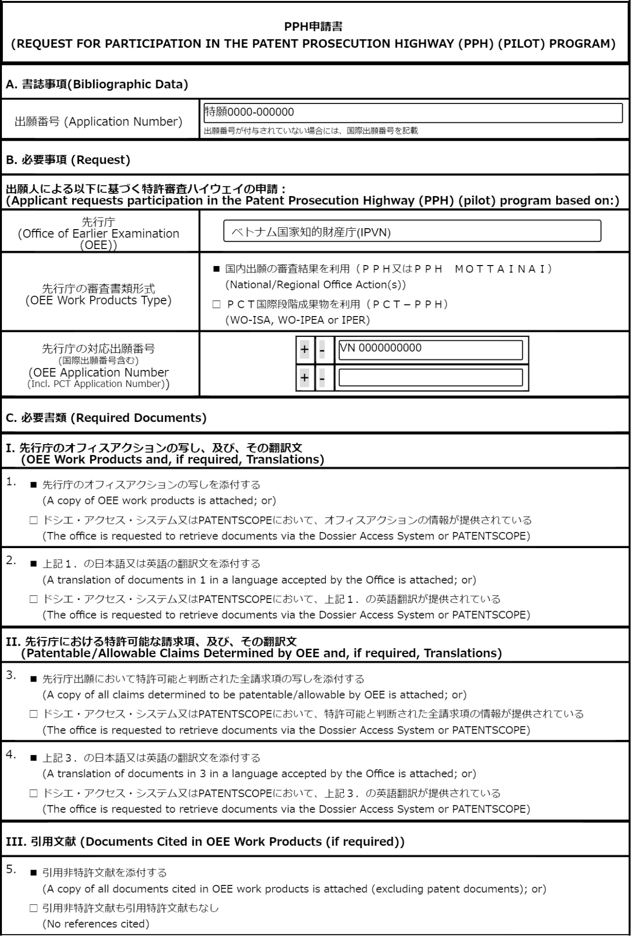

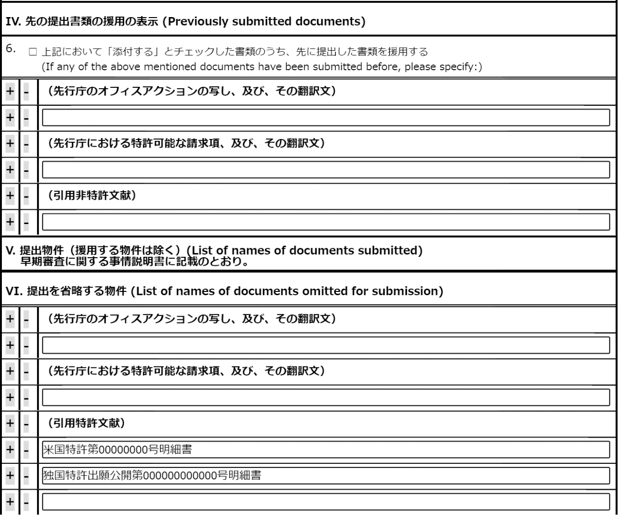

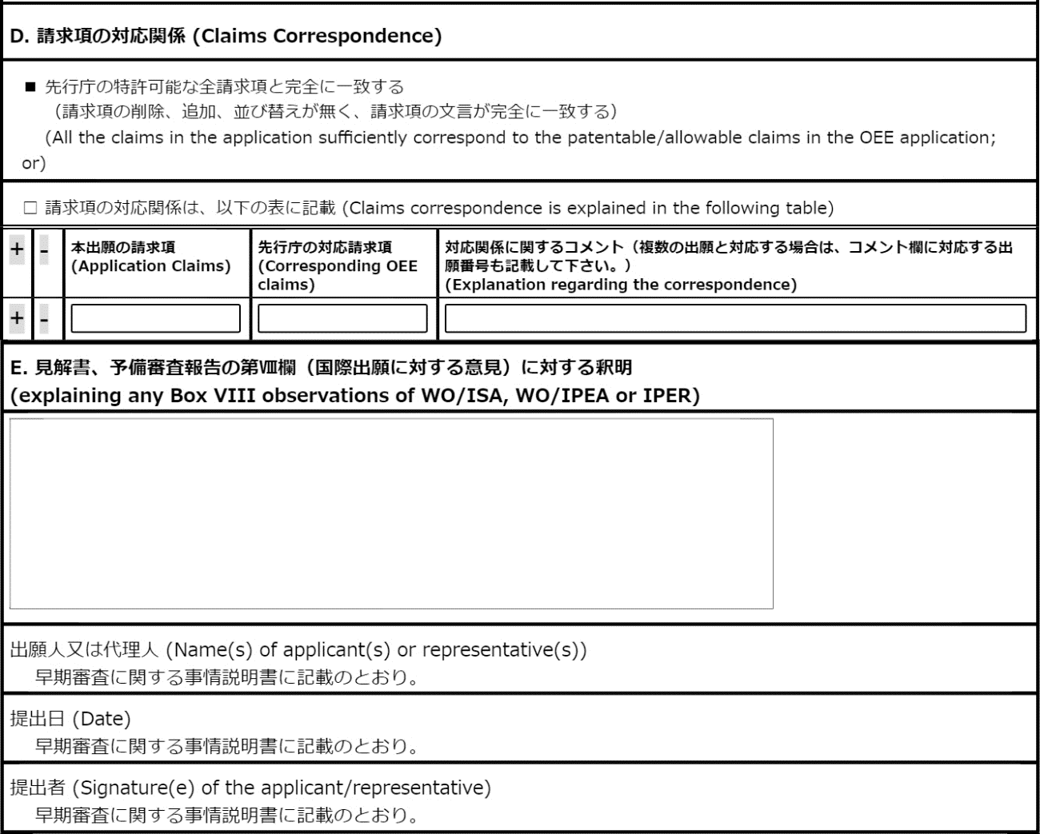

【物件名】 **年**月**日付の拒絶理由通知書及びその翻訳文
Copy and translation of Notification of Reasons for Refusal in the IP Viet Nam on (date)
Use the same name as “【物件名】” under “【提出物件の目録】.”

【内容】
Attach the copy of the document.

【物件名】 **年**月**日付の特許査定およびその翻訳文
Copy and translation of grant in the IP Viet Nam on (date)

【内容】
Attach the copy of the document.

【物件名】 特許可能と判断された請求項の写し及びその翻訳文
Copy and translation of the claims indicated patentable in the report on the state of the art and written opinion in the IP Viet Nam on (date)

【内容】
Attach the copy of the document.

【物件名】 引用非特許文献１
Cited non－patent literature1

【内容】
Attach the copy of the document.

Note that in the case of paper procedure, the pendency period (the period between the request for PPH and the first office action) tends to be longer than on-line procedure.

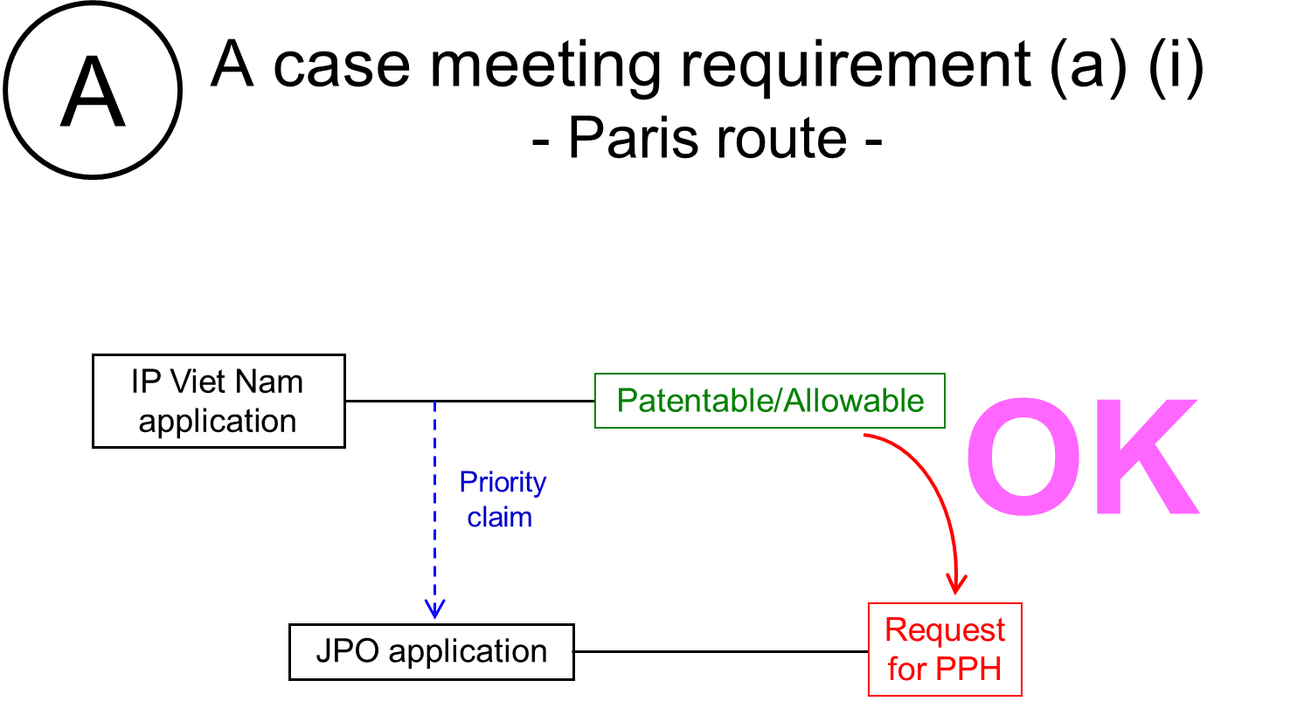

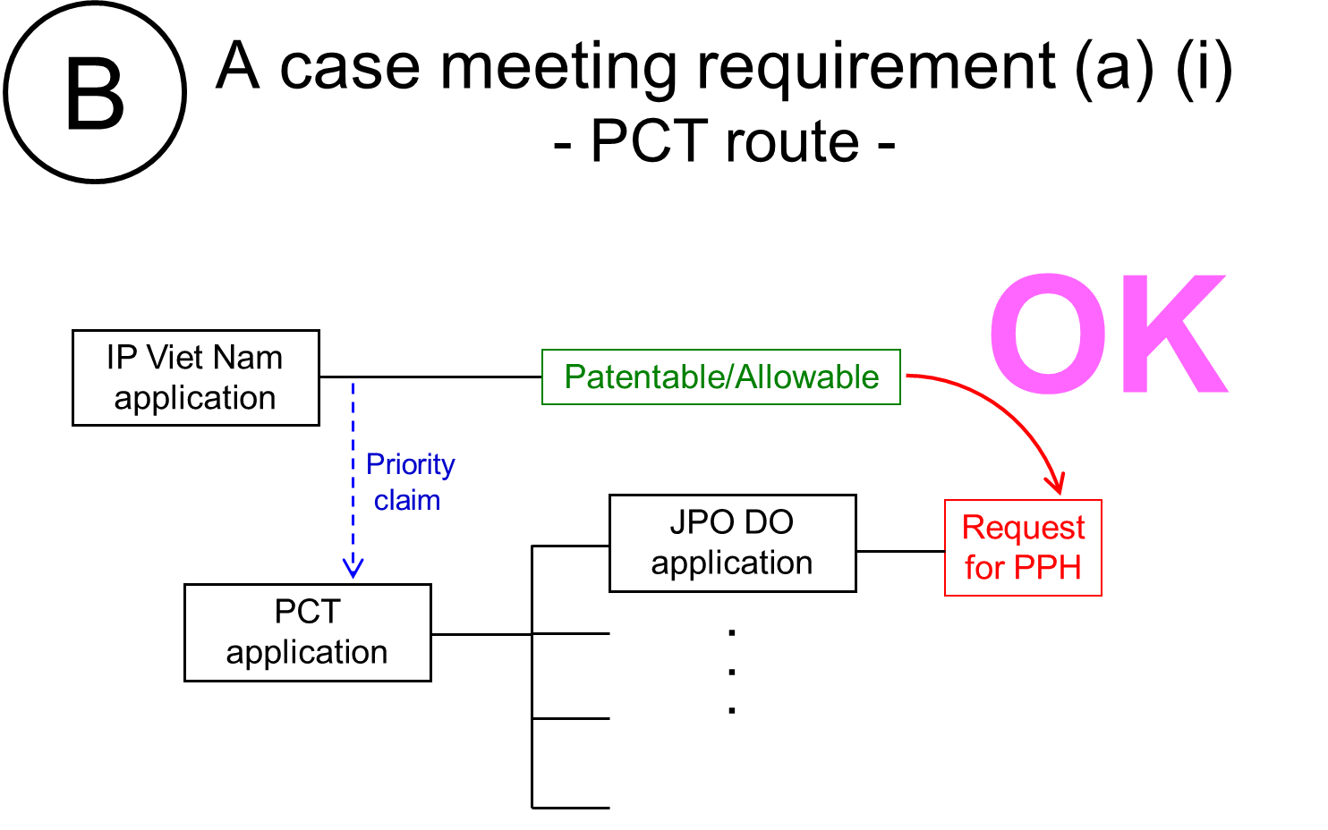

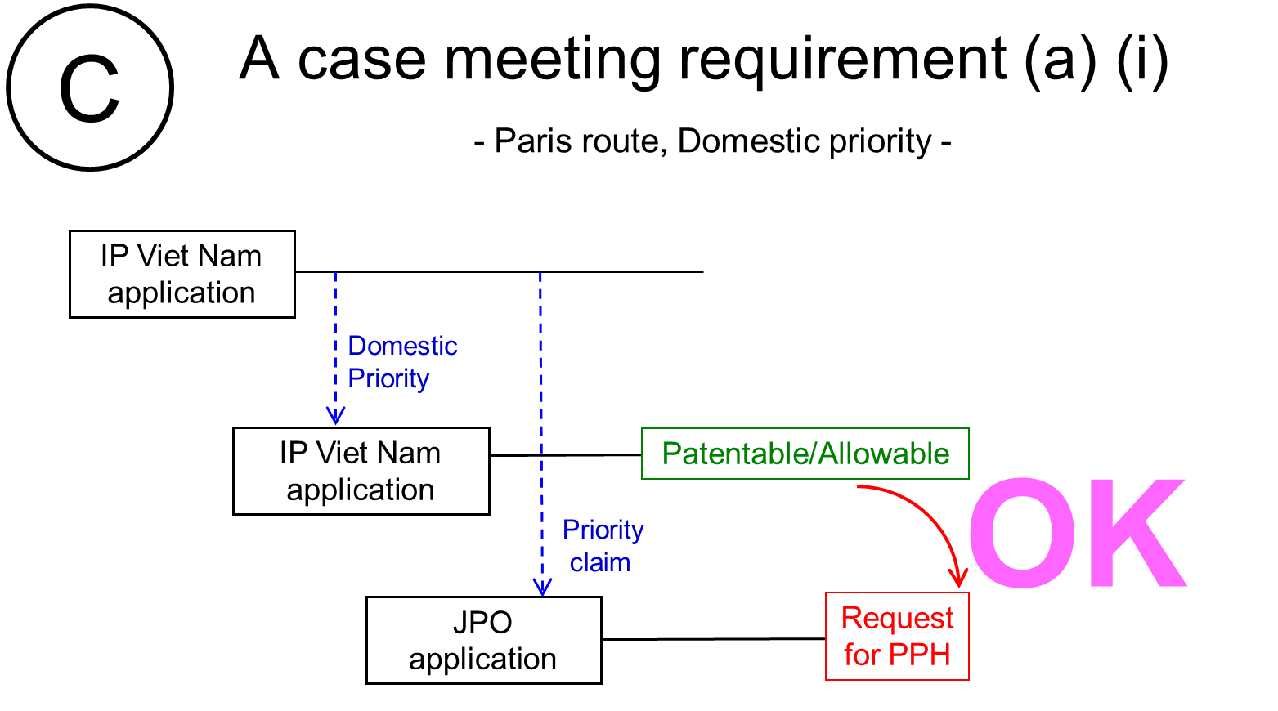

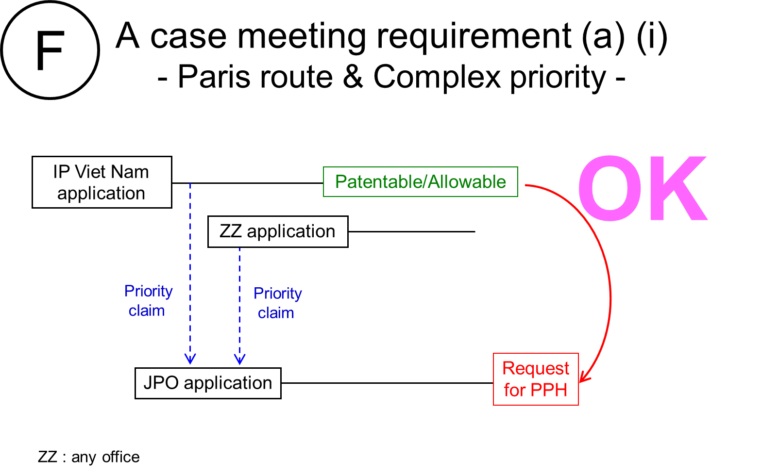

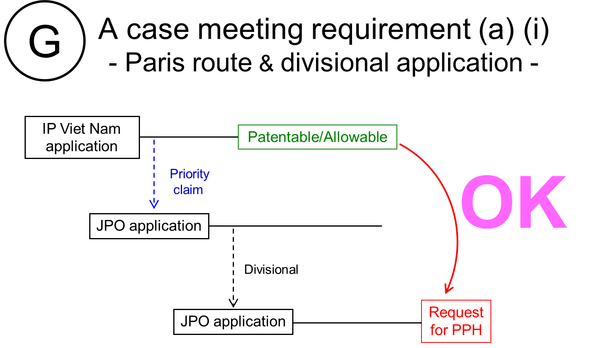

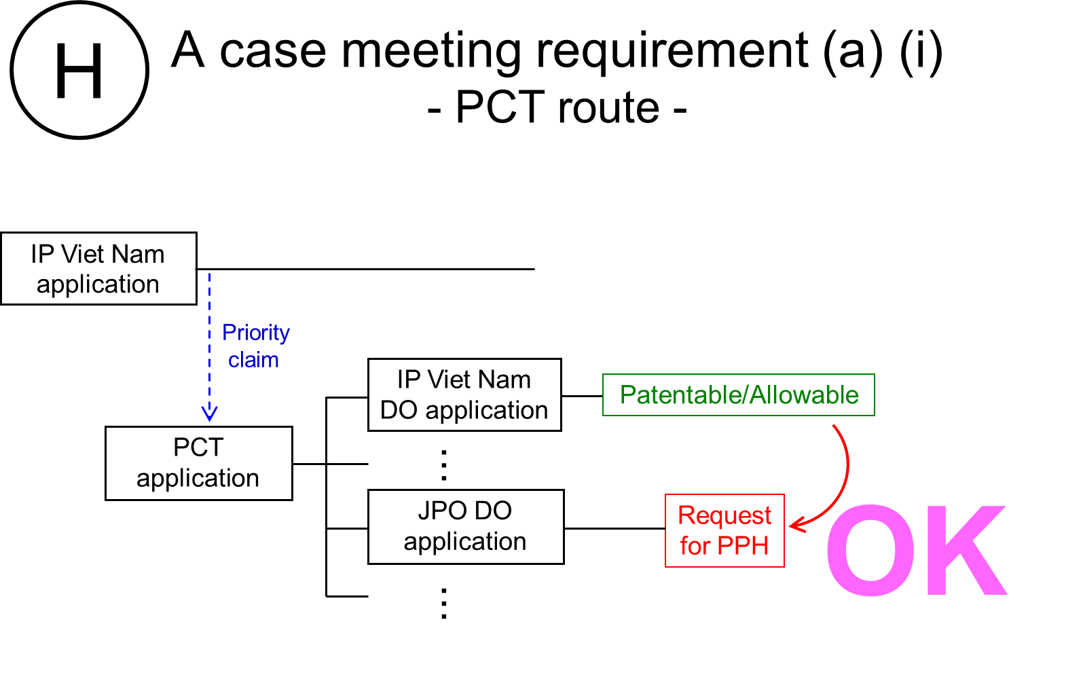

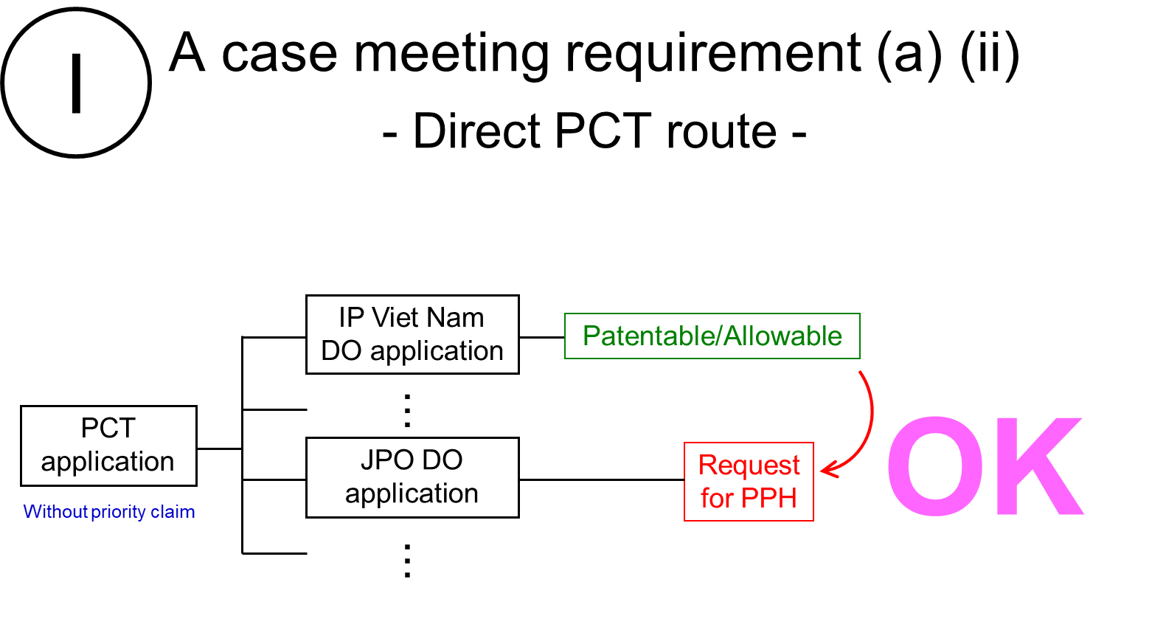

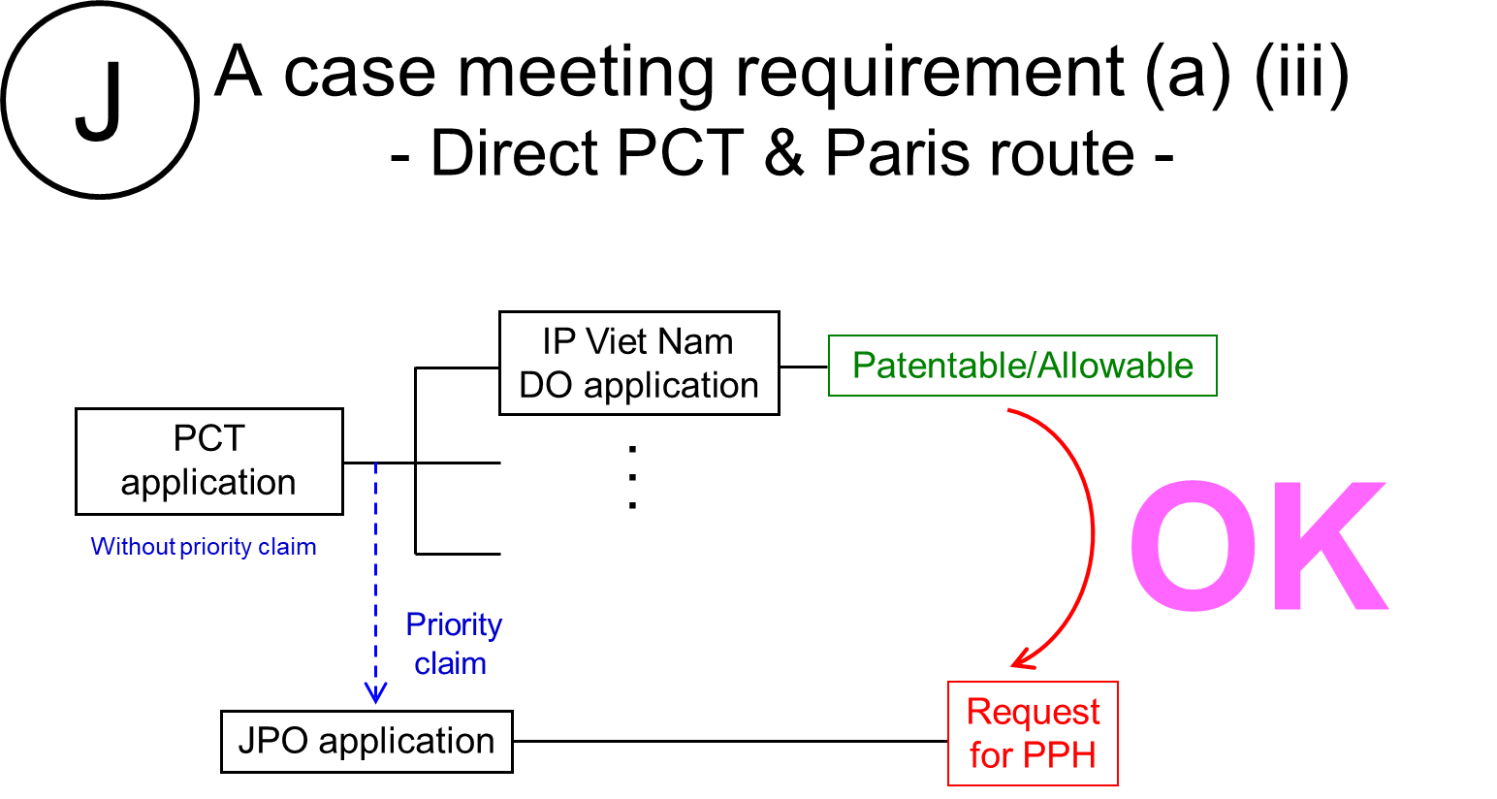

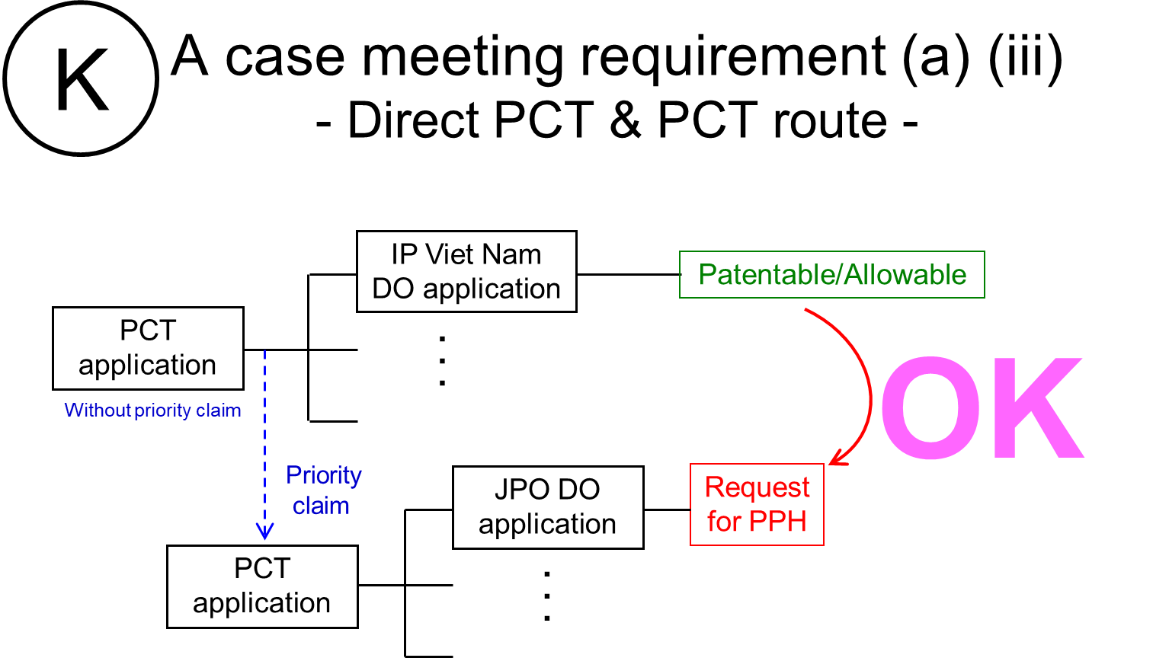

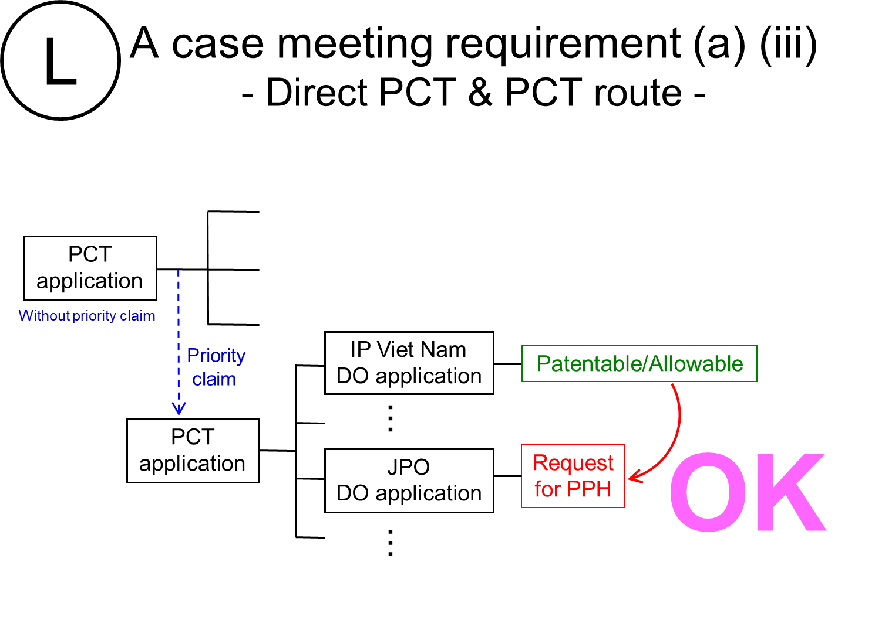

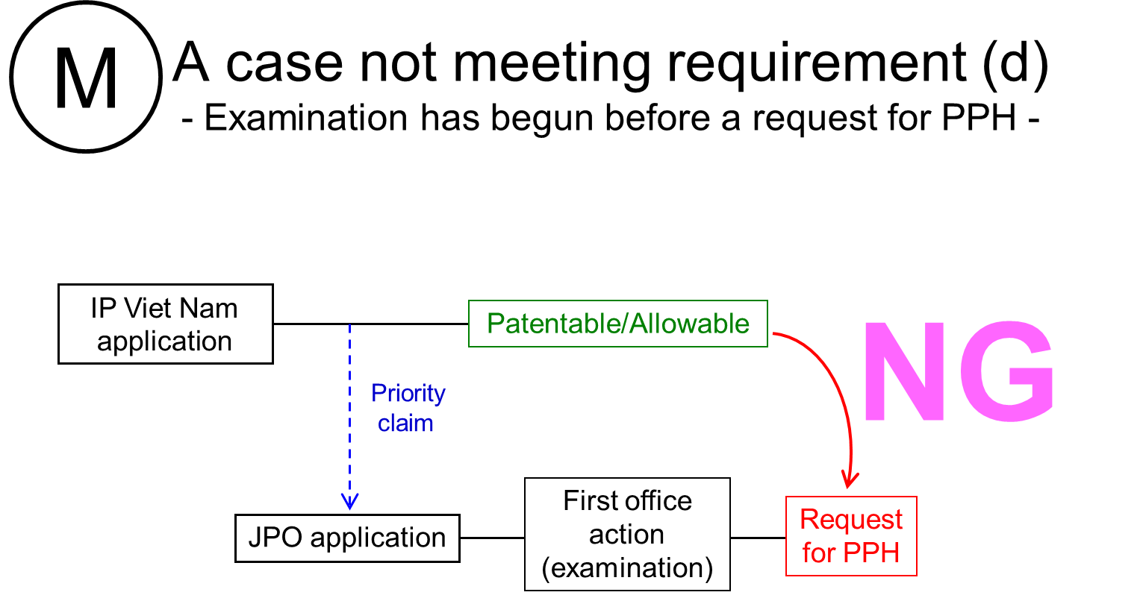

https://www.jpo.go.jp/e/system/patent/shinsa/jp-soki/document/index/guideline.pdf (in Japanese)
Machine translations will be admissible, but if it is impossible for the examiner to understand the outline of the translated office action or claims due to insufficient translation, the examiner can request the applicant to resubmit translations.
https://www.jpo.go.jp/e/system/patent/shinsa/jp-soki/document/index/guideline.pdf (in Japanese)

